# Mobile Apps

* Notification Hub is necessary
  + They need a namespace
  + Then the Hub can be connected to the specific providers:
  + 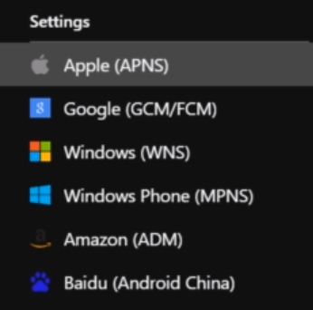

**What are the two ways of storing Easy Tables Data?**

SQL Database, Storage Account